**Fact Sheet - Classification**

**Classification and Records Management**

The Australian Standard for Records Management, AS ISO 15489, defines classification as the:

systematic identification and arrangement of business activities and/or records into categories according to logically structured conventions, methods, and procedural rules represented in a classification system.

A classification system is the set of terms and conventions applied in an agency to classify, title and retrieve records and other business information.

It controls the vocabulary used, generating consistency in the description of information produced by business activities and improving retrieval of that information. Classification tools for records management can also be extended to assist sentencing and disposal.

**Classification by Function**

Functions and activities provide a more stable framework for classification than organisational structures that are often subject to change through amalgamation, devolution and decentralisation.

The structure of an organisation may change many times, but the functions an organisation carries out usually remain much the same over time.

A functions-based classification has further advantages, as it helps to:

* Identify records that should be created because of their evidential value for business.
* Recognise high priority records that should be captured because of their business significance.
* Make decisions on retention.
* 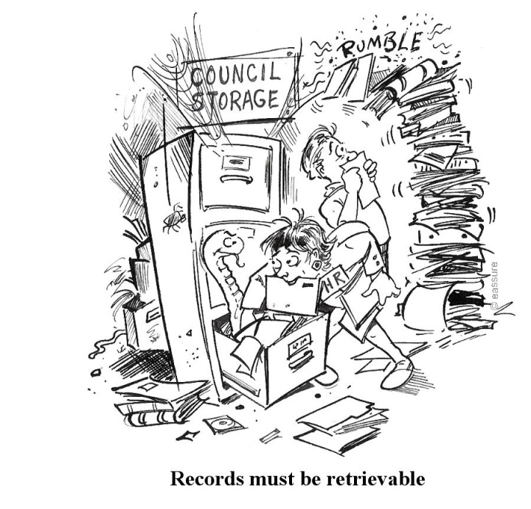Sentence records at the point of creation.

**Business Classification Scheme (BCS)**

A [Business Classification Scheme](http://intranet3.csv.au/facs/fbs/business-support/records2/managing-records/Classifiers-Guide.pdf) is a common vocabulary used to structure the titles of corporate files.

The scheme is a two-tier hierarchy of predefined terms, moving from broad business functions to specific business activities.

Broad terms represent the functions of the organisation and each broad term has a defined subset of narrower terms to represent activities undertaken within the function.

Each corporate file title is comprised of three levels. The first and second levels are selected from the Classification Scheme and the third level consists of user defined free text.

**Resolving Business Problems**

Some problems that a well-designed business classification scheme can overcome include:

* Low success in retrieving required records and other information.
* Retrieval of too many records or too much information.
* Retrieval of unrelated and unwanted records and other information.
* Use of incorrect terminology for searching.
* Scattering of records and other information across different sources or business information systems.
* Multiple terms used to describe the same project.
* Inability of users to decide on the best terms to use for searching.
* Inability of users to decide on the best way to classify or describe the records they create.

Please contact the Records Office for further information on classification and using the Business Classification Scheme.