**Records Disposal**

What is Records Disposal?

Records disposal is an important part of efficient and effective records management. It is the process of retaining, transferring, or destroying records.

Disposal is defined as a range of processes associated with implementing the retention, deletion, destruction or transfer of records.

The lawful disposal of records is an essential and critical component of any records management programme.

These define the minimum retention periods and consequent disposal action authorised for classes of public records

What is a Disposal Authority?

Disposal authorities are issued by the Keeper of Public Records and are a legal instrument authorising the destruction or transfer of public records.

They define the minimum retention time that different classes of records must be kept and how they are to be disposed of. They authorise the destruction of time-expired records. They also identify records that are to be permanently retained as State Archives.

Disposal authorities ensure the disposal of public records is open, transparent and accountable and can be authorised via the following tools:

* **Retention & Disposal Authorities (RDAs)**

RDA’s provide continuing authorisation for the disposal of identified classes of records based on the functions and activities of agencies.

* **Single Instance Disposal Authorities (SIDAs)**

Single Instance Disposal Authorities may be used when there is no existing disposal coverage and the records relate to a function or activity which is not currently performed by the agency.

* **Normal Administrative Practice (NAP)**

NAP covers the destruction of ephemeral material of a facilitative or duplicate nature created, acquired or collected by public sector employees during the course of their duties.

Public records may be destroyed by a public sector employee without any authorisation from PROV provided that they fall within the category of Normal Administrative Practice (NAP). NAP allows for the disposal of:

* Working documents consisting of rough notes and calculations used only as a means to assist in the preparation of other records such as correspondence, reports and statistical tabulations.
* Drafts not intended for retention as part of the agency’s records, the content of which has been reproduced and incorporated in the agency’s recordkeeping system.
* Additional copies of documents, emails and publications maintained for reference purposes.

The decision to destroy records under NAP is the responsibility of the agency. The agency is responsible for ensuring that all staff understand NAP and are able to apply it correctly in their day to day work, for instance, in the management of email records.

The following factors should be considered:

* Is there any further administrative need to retain the record?
* Are others still using the record?
* If you believe it’s just a copy, are you sure that an authoritative version has been kept?

Retention & Disposal Authorities

There are currently three Retention & Disposal Authorities are relevant to the main functions and activities performed by Local Government agencies:

***PROS 07/01 General Retention & Disposal Authority for Records of Common Administrative Functions***

***PROS 09/05 Retention & Disposal Authority for Records of Local Government Functions***

These may not apply to all records and if an applicable retention period cannot be identified, contact the Records Office for assistance.

NB: Retention & Disposal Authorities apply equally regardless of format (i.e. scanned records, electronic records or paper records).

Legislative Provisions

Under section 19 of the *Public Records Act 1973*, it is an offence to unlawfully destroy a public record.

Destruction of a record is unlawful if it is not done in accordance with standards established under section 12 of the Act.

In addition, government agencies should not destroy records that are the subject of a current Freedom of Information (FOI) request until all avenues of appeal have been met.

The *Crimes (Document Destruction) Act 2006* makes it an offence for an individual or organisation to destroy a document or other object that is reasonably likely to be required in evidence of a legal proceeding.

While the Act does not criminalise normal records disposal (including disposal formally authorised under a relevant Public Record Office Victoria Retention & Disposal Authority, or RDA), it will not be possible to use an RDA to legalise or justify the destruction of document or records where that destruction meets the criteria of an offence under the Act.

Business Benefits

A well-developed disposal programme can improve practices across the agency by establishing records management best practice through a structured, regular disposal programme that is risk adverse and manages all records through to the end of their lifecycle.

A planned disposal programme:

* Makes more efficient use of resources, reducing storage and maintenance costs.
* Enhances access to existing records by only retaining required records.
* Assists with identification of records required for Freedom of Information (FOI) requests, subpoenas and discovery in general.
* Ensures records are kept for the correct period of time.
* Identifies permanent records, enabling appropriate management prior to transfer to PROV.
* Provides for the systematic management of agency records and reduces risk, and
* Assists with legislative compliance.

Secure destruction

Confidentiality of some information may be compromised through the careless disposal of potentially sensitive material. Disposal of such material via non-secure destruction bins is not permitted as it significantly increases the risk of unauthorised access to information, breach of privacy and divulging commercial information.

When disposing of working documents, and other reference materials which are no longer required for business purposes, it is vital that appropriate disposal facilities are used to protect sensitive information they may contain.

The key principle is that any material containing potentially sensitive information must be disposed of using secure facilities, i.e. designated bins for paper records and an identified bin for electronic storage media. Non-sensitive material should be placed into normal office paper recycling bins.

Proof of destruction may be required in litigation proceedings, in response to FOI requests or as requested from PROV.

Sentencing Records (Flow chart attached)

Sentencing is the process of using a Records & Document Authority, General Disposal Authority or Normal Administrative Practice to decide whether to retain, destroy or transfer a record.

**Step 1**

**Are the records administrative or agency core business records?**

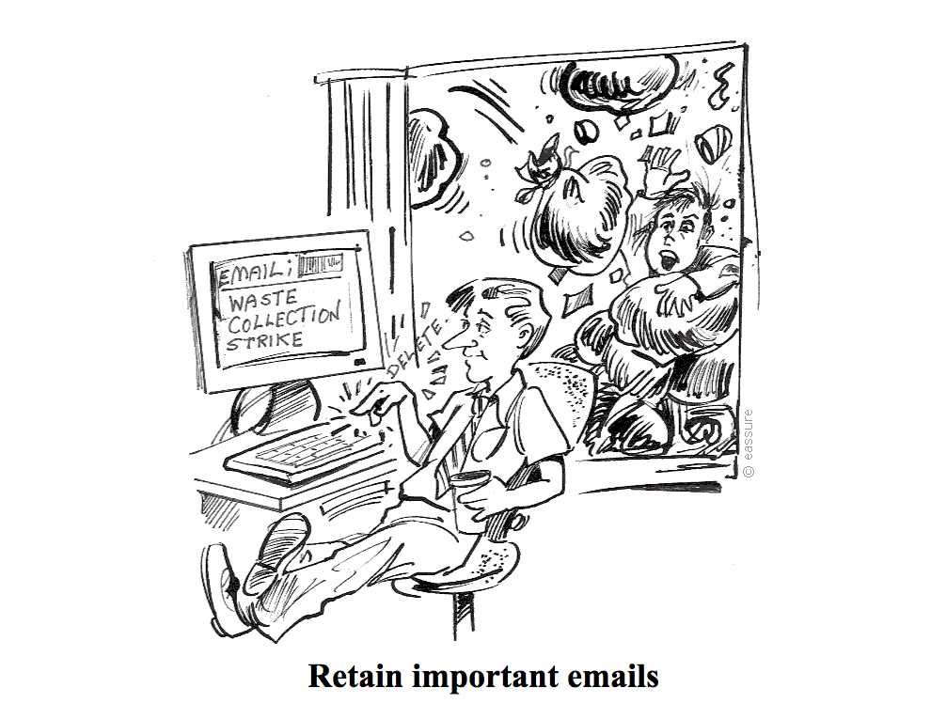For routine administrative records, use PROS 07/01 General Retention & Disposal Authority for Records of Common Administrative Functions

For records of agency core functions, use PROS 09/05 Retention & Disposal Authority for Records of Local Government Functions or other relevant Retention and Disposal Authority.

**Step 2**

**Identify the relevant disposal class.**

The record title or format will give you a clue as to the record contents. However, these can be misleading or inaccurate, particularly with older records. Be sure to check the contents during sentencing to confirm the decision.

Use the class description or examples in the disposal authority to help select the appropriate retention and disposal class. If more than one class is appropriate, choose the one with the longest retention period.

If you cannot find a disposal class that fits, contact Records Services for assistance.

**Step 3**

**Calculate the minimum retention period**

To calculate the minimum retention period for a record, you need to consider both the disposal action (time period) and disposal trigger.

Note that the disposal trigger, e.g. after last action, after equipment superseded, as these have to be met before any disposal action can be performed.

Ensure the relevant disposal class and the minimum retention period are written on or attached to the record for reference

**Step 4**

**Confirm that the minimum retention period has been met**

If the retention period has yet to be reached, or the disposal trigger has yet to be met, set a review date for the future.

**Step 5**

**Complete records destruction form**

Complete form with details of record groups, retention class, retention period and destruction date. This is to be signed off by departmental management and forwarded to Records Services.

Once the form has been completed destruction of the records can be performed.

**Step 6**

**Update control records**

Records Services to update the EDRMS and/or a disposal register (Example Form Attached) with information that documents what happened to the records, and under what authority it was disposed of.

Physical Processing (Boxing) of Records

Those records which have been sentenced but for which the retention period has been met, need to be stored until the disposal trigger has been met.

**How to pack records**

Pack records with similar retention periods together, or those records which belong to similar functions and/or activities.

Records should be boxed in appropriate boxes or containers, usually standard 'Type 1' box, or in archive box provided by storage provider. These boxes are designed to hold foolscap and A4 files and papers. Do not use large packing boxes.

Do not overfill boxes. There should be enough space for a clenched fist between the contents and one side of the box.

Remove the following items from the records:

* Paperclips
* Bulldog clip
* Plastic sleaves
* Elastic bands

Use cotton archival tape around documents that need to be kept together.

**How to list records**

The information required about each record item includes:

* Container/box number
* Item number or control symbol, e.g. file number or other unique identifier
* Item title or description. File title may be adequate but, if it does not clearly indicate the content of the item, add additional information. If the item has no title, provide a brief, concise description.
* Do not use acronyms or abbreviations in the item titles.
* Do not use superscript or subscript fonts.
* Date range of the item, e.g. date file was created and closed
* Ongoing Access Restrictions, e.g. Personnel Files.

**Place completed list inside box on top of contents**

**Records Sentencing Flowchart**



|  |  |  |
| --- | --- | --- |
|  | Records Destruction Register Authorisation & Notification | Records Office Only |

|  |  |  |  |
| --- | --- | --- | --- |
| Department: |  | | |
| Contact Name: |  | Title: |  |
| Email: |  | Phone: |  |

|  |  |  |  |  |  |
| --- | --- | --- | --- | --- | --- |
| Disposal Schedule:  **NB: You must use a separate form for each disposal schedule. A single form cannot be used for multiple schedules.** |  | PROS 07/01 General Disposal Authority for Common Administrative Records | | | |
|  | PROS 09/05 Retention and Disposal for Records of Local Government Functions | | | |
| Method of destruction (tick method used): | | | Pulping | Shredding | Burning |

| Description of records: | | | | |
| --- | --- | --- | --- | --- |
| **Item No.** | **Disposal Class No.** | **Records Title and/or Description**  **(including any reference numbers or control symbols)** | **Date Range** | **Quantity** |
|  |  |  |  |  |
|  |  |  |  |  |
|  |  |  |  |  |
|  |  |  |  |  |
|  |  |  |  |  |
|  |  |  |  |  |
|  |  |  |  |  |
|  |  |  |  |  |
|  |  |  |  |  |
|  |  |  |  |  |
|  |  |  |  |  |

|  |  |  |  |
| --- | --- | --- | --- |
| **Manager/Supervisor approval for the destruction of listed records:** | | | |
| Name: |  | Title/Position: |  |
| Signature: |  | Date: | /     / |

|  |  |  |  |  |  |
| --- | --- | --- | --- | --- | --- |
| **Litigation Signoff** | | | | | |
| As of the *(day)* *(month)* *(year)* there is no known litigation for which these records are, or are likely to be, required in evidence of a legal proceeding. | | | | | |
| Name: |  | Position: |  | Signature: |  |